Nama : Estu Nosita

NIM : 18090070

Kelas : 5C

TUGAS PERTEMUAN 5

1. Source Code

Autolod.php => application / config.php

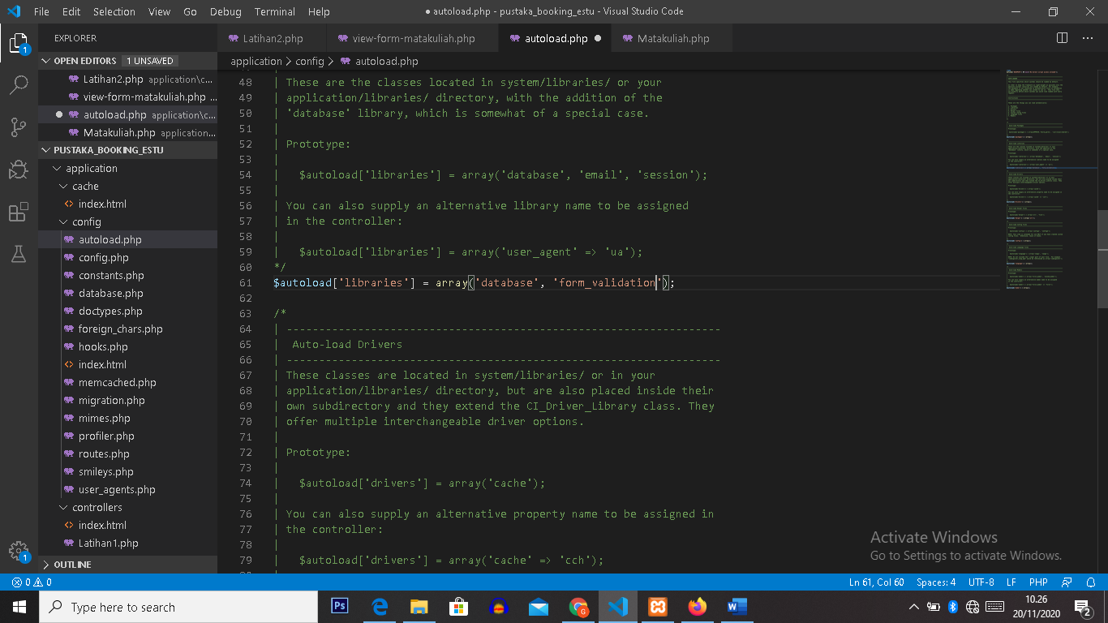

MatakuliahValidation.php => application / controller

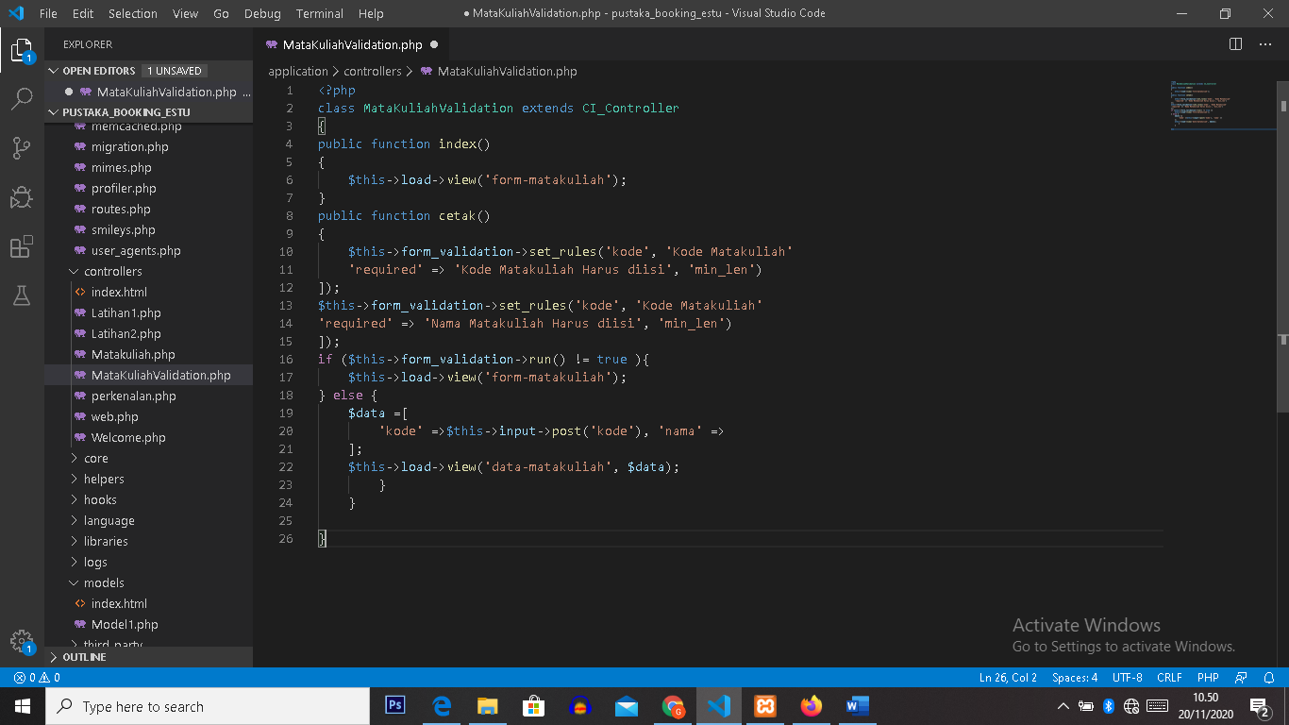

Form-matakuliah.php => application / views

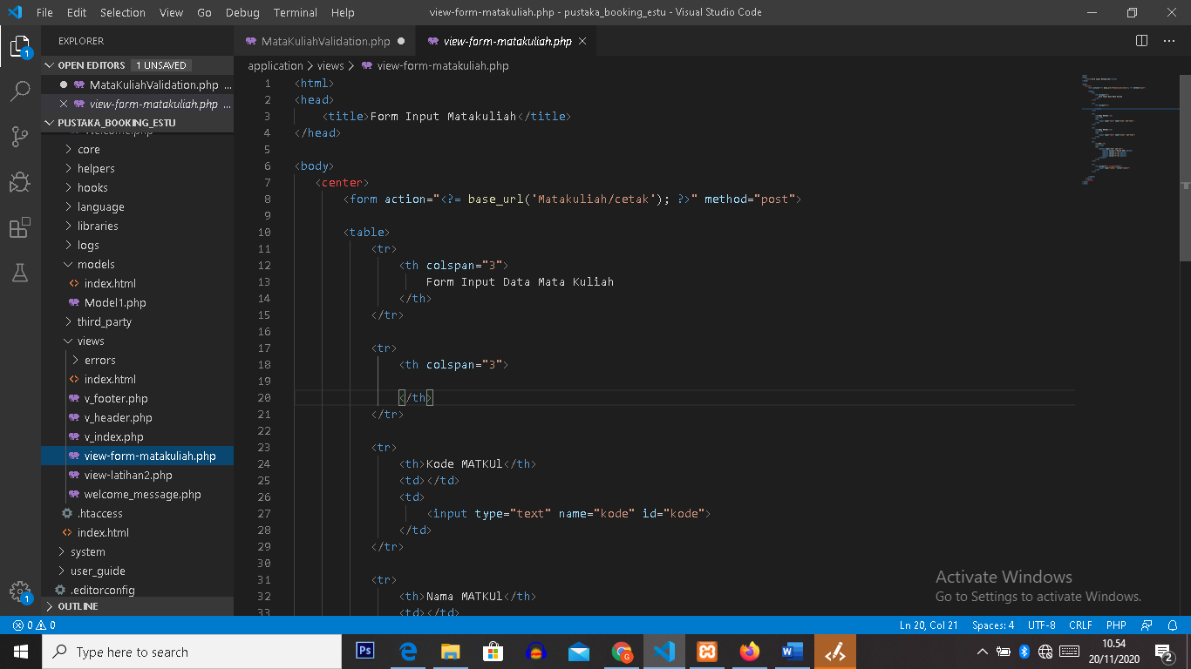

1. URL

<http://localhost/pustaka_booking_estu/index.php/MatakuliahValidation>

1. Capture Hasil

